- Window: -

✅ 1. What is Custom Script?
A Custom Script is simply a script file you write to automate work inside a VM, such as:
- Installing Apache/Nginx
- Creating users
- Improving configuration
- Downloading app code
- Running commands after VM creation
Examples:

Bash (Linux):
#!/bin/bash
apt update
apt install nginx -y

PowerShell (Windows):
Install-WindowsFeature -Name Web-Server
➡️ This script itself is called Custom Script.

✅ 2. What is Custom Script Extension?
Custom Script Extension is an Azure VM Extension that allows Azure to:
- Inject your custom script into a VM
- Download script from URL or storage
- Run it automatically
- Show logs of execution
➡️ It is a tool/service inside Azure that runs your script on the VM.

Simple meaning:
- Custom Script = Your script
- Custom Script Extension = Azure feature that runs your script inside the VM

🟢 3. Two Ways to Run Custom Script Using Custom Script Extension

Way 1: Direct Method (Upload or Command) — Easiest
You directly upload your .sh or .ps1 file
OR type the command.

Way 2: Storage Account Method (Public blob, No SAS Token)
You upload your script to a public-access blob
Then paste the file URL in Custom Script Extension.

🟩 4. Step-by-Step Guide

WAY 1 — Direct Custom Script Execution (Upload Script or Type Commands)

When u create the vm at the time of advanced there is script extension in that u type custom script extenstion and add there from your laptop or from storage account.

Step 1: Go to your VM → Extensions + applications

Step 2: Click + Add

Step 3: Select Custom Script Extension

Step 4:
You will see two options:
🔘 Upload file
🔘 Provide script command

Option A: Upload your script file (.sh or .ps1)
- Create a script, example apache.sh:
- #!/bin/bash
- apt update
- apt install apache2 -y
- Upload it in Custom Script Extension
- Click OK
Azure will run the script in your VM.

Option B: Direct Command (No script file)
If you don’t want to upload any file:
Type your command in the box:
Example (Ubuntu):
apt update && apt install nginx -y
This will run directly inside the VM.

🟩 5. WAY 2 — Use Storage Account (WITHOUT SAS TOKEN)
This is possible only when you use Public Access.

Step 1 — Create Storage Account
Home → Storage accounts → Create

Step 2 — Create container
Storage account → Containers → + Container
Name: scripts
Public access level: Blob (anonymous read access)
▶️ Important: This allows NO SAS token required

Step 3 — Upload your script
Upload apache.sh or any script.
Example script:
#!/bin/bash
apt update
apt install apache2 -y

Step 4 — Copy script URL
Example URL:
https://mystorage123.blob.core.windows.net/scripts/apache.sh

Step 5 — Add Custom Script Extension in VM
VM → Extensions + applications → Add → Custom Script Extension
Select Provide Script via URL
Paste the file URL:
https://mystorage123.blob.core.windows.net/scripts/apache.sh
Azure will:
- Download this script from blob
- Run it inside the VM
- Show output logs
2)for linux-You create the script and store that in storage account container in “.sh” extension.after that create the vm of linux and in advanced section click on install script extension. Add type custom linux for linux and select script that is stored in storage acc. And run …after that take public ip of vm and in browser http://ip.

3)cloud init:- Nice — cloud-init is the easiest way to bootstrap Linux VMs on first boot. Below I’ll explain what it is, what it does on Azure, and give practical step-by-step instructions (Portal, Azure CLI, ARM template) plus a ready-to-use cloud-init YAML example and troubleshooting tips.

What is cloud-init?
cloud-init is a cross-platform initialization tool used by most Linux cloud images to perform first-boot configuration. With cloud-init you can:
- create users and set SSH keys
- install packages
- write files
- run commands/scripts
- enable services, set hostname, configure networking (depends on image)
On Azure, cloud-init is supported by official Linux images (Ubuntu, CentOS, RHEL, etc.). You supply a cloud-init YAML as custom data (aka customData) and the VM runs it automatically during its first boot.

Key facts to remember
- cloud-init runs on first boot by default. To re-run, you must clean/reset it.
- The cloud-init data is plain YAML. Use sections like users, packages, write_files, runcmd.
- Azure customData size is limited (practical limit ≈ 64 KB). For ARM: customData must be base64 encoded.
- Logs: /var/log/cloud-init.log and /var/log/cloud-init-output.log on the VM.
- Use an image that contains cloud-init (most official cloud images do).

Example cloud-init YAML (install Apache, create user, set SSH key)
Save this as cloud-init.yaml:
#cloud-config
hostname: my-azure-vm
manage_etc_hosts: true

users:
- name: jumpuser
gecos: "Jump User"
sudo: ALL=(ALL) NOPASSWD:ALL
groups: sudo
shell: /bin/bash
ssh_authorized_keys:
- ssh-rsa AAAA...your_public_key... user@host

packages:
- apache2 # Ubuntu example; use httpd for RHEL/CentOS

write_files:
- path: /var/www/html/index.html
content: |
<html><body><h1>Deployed by cloud-init</h1></body></html>
owner: root:root
permissions: '0644'

runcmd:
- [ systemctl, enable, apache2 ]
- [ systemctl, start, apache2 ]
- [ curl, -fsS, "https://example.com/health-check" ] # optional
Notes:
- Change SSH public key to your key.
- For RHEL/CentOS replace apache2 with httpd and service names accordingly.
- runcmd executes after packages are installed and files are written.

Option A — Create VM and provide cloud-init via Azure Portal (simple)
- Azure Portal → Create a virtual machine.
- Under Basics choose Linux image (Ubuntu/CentOS that supports cloud-init).
- Go to Advanced tab.
- In Cloud-init / Custom data box paste the contents of cloud-init.yaml. (Portal label may be Custom data or Cloud-init depending on UI.)
- Finish VM creation.
Azure will pass that data as customData and the VM will run cloud-init on first boot.

4)azure boot diagnostic:-IT IS BY DEFAULT ENABLED.
✅ What is Azure Boot Diagnostics?
Azure Boot Diagnostics is a troubleshooting and debugging feature for Azure Virtual Machines.
It helps administrators understand what happened during the boot process when a VM fails to start properly.
Boot Diagnostics collects boot logs and screenshots directly from the VM’s hypervisor.
The type of data collected depends on the operating system:

🟦 How it works on Linux VMs
For Linux-based VMs, Boot Diagnostics captures:
- Serial Console Output (logs produced during boot)
- Kernel messages
- Cloud-init and system boot logs
This helps diagnose issues such as:
- Kernel boot errors
- Cloud-init failures
- File system mounting problems
- Incorrect configuration
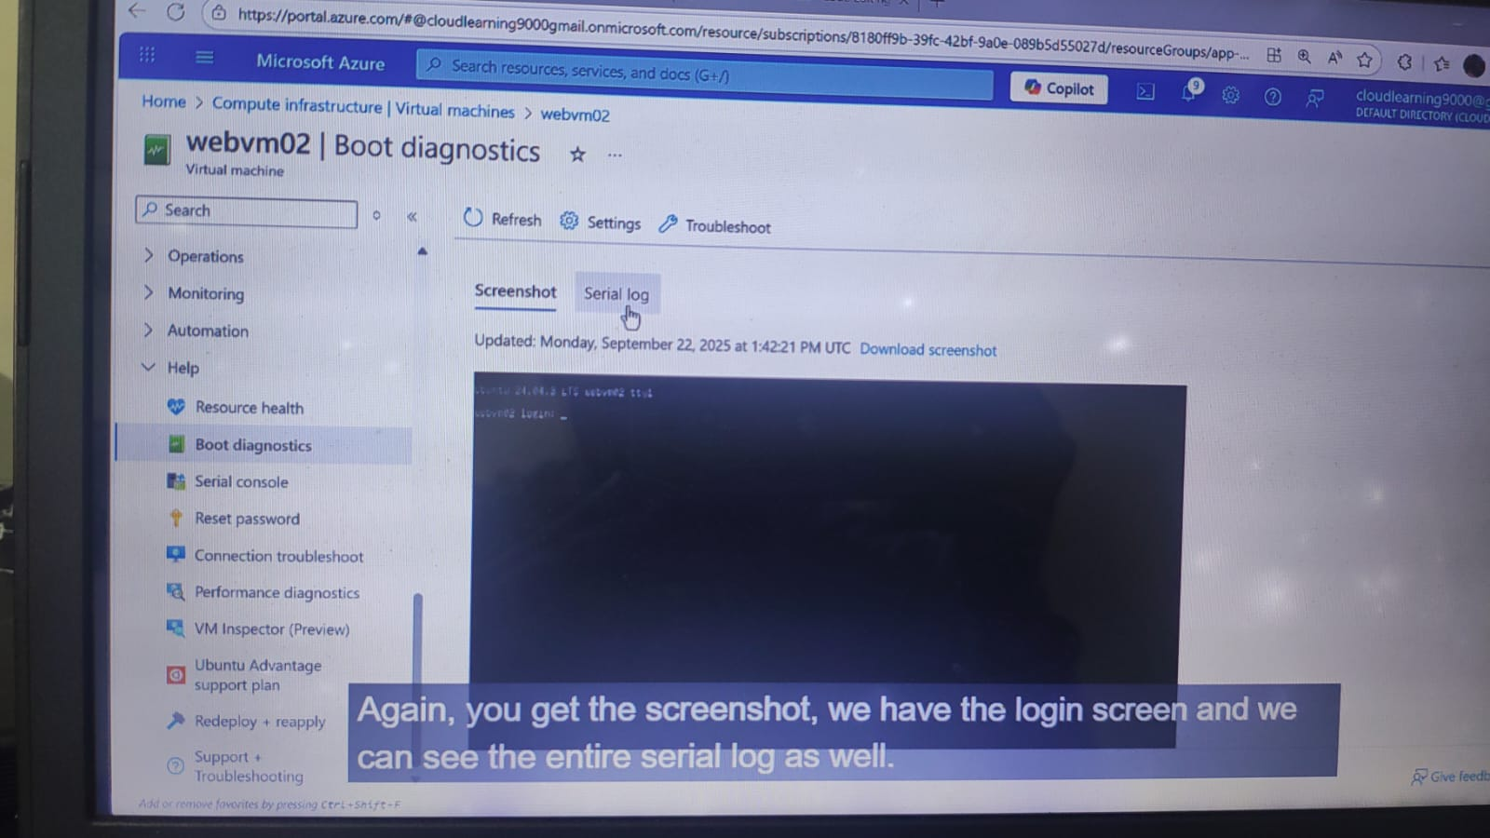

🟩 How it works on Windows VMs
For Windows-based VMs, Boot Diagnostics captures:
- A screenshot of the VM console during boot
Why?
Because Windows does not output serial console logs like Linux.
A screenshot helps identify issues such as:
- Stuck on Windows Update
- Blue screen (BSOD)
- Boot loader errors
- Login screen issues

